|  |
| --- |
| Chukong Technologies |
| Shaders and Materials |
| PC-3DMAX |

|  |
| --- |
| lvlong |

Contents

1 Shaders and Materials 0

2 Shader 0

3 Material 0

4 Debug 1

# Shaders and Materials

The *.vsh/*.fsh files are a way of defining how an object is rendered within the cocos3d-x engine.

The *.material files are meta-data files that contain artist-editable features, including shader file, shader properties, and texture references. ModelEditor can create and modify material files that can be assigned to mesh objects.。

# Shader

cocos3d-x ships with some commonly used shaders, which can be found in the Resources/3d/shaders folder。

# Material

A material can contain multiple Techniques (for example, we can use one technique for normal rendering and another for shadow rendering); A technique can also contain multiple pass.。

Selected shader for current pass

Select macros for current shader

Uniform parameters for current shader

Render states for current pass

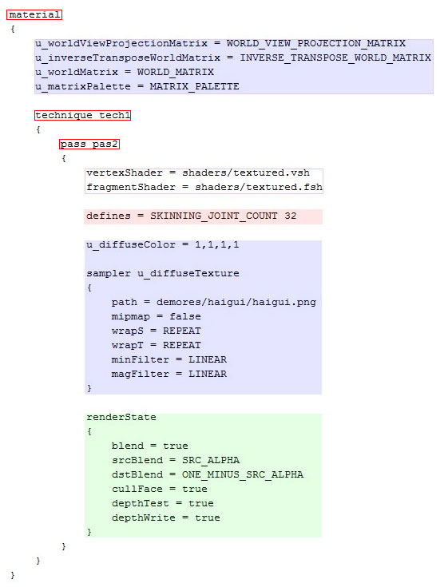

Tips: 1: Above, the basic structure supported by the cocos3d-x engine material script, the parameters of the first blue region using the automatic assignment mechanism by the cocos3d-x engine, cocos3d-x also supports the following common values of automatic assignment:：

// Binds a node's World matrix.

WORLD_MATRIX,

// Binds the View matrix of the active camera for the node's scene.

VIEW_MATRIX,

// Binds the Projection matrix of the active camera for the node's scene.

PROJECTION_MATRIX,

// Binds a node's WorldView matrix.

WORLD_VIEW_MATRIX,

// Binds the ViewProjection matrix of the active camera for the node's scene.

VIEW_PROJECTION_MATRIX,

// Binds a node's WorldViewProjection matrix.

WORLD_VIEW_PROJECTION_MATRIX,

// Binds a node's InverseTransposeWorl matrix.

INVERSE_TRANSPOSE_WORLD_MATRIX,

// Binds a node's InverseTransposeWorldView matrix.

INVERSE_TRANSPOSE_WORLD_VIEW_MATRIX,

// Binds the position (C3DVector3) of the active camera for the node's scene.

CAMERA_WORLD_POSITION,

// Binds the view-space position (C3DVector3) of the active camera for the node's scene.

CAMERA_VIEW_POSITION,

// Binds the matrix palette of C3DMeshSkin attached to a node's model.

MATRIX_PALETTE,

// Binds the total time and delat time.

TIME_PARAM,

2： Valid attributes and macros used by the material script depends on the shader’s impliments.

# Debug

Developers can use the model editor for material script debugging.

